A Major Project Proposal on
NextGen Prep
Submitted in partial fulfillment of the requirements for the degree of
Bachelor of Engineering in Software Engineering at Pokhara
University
By
Anil B.K
Kriti Adhikari
Nirakar Bikram Rana


Department of Research and Development
GANDAKI COLLEGE OF ENGINEERING AND SCIENCE
Lamachaur, Kaski, Nepal
(June 19, 2025)

A Major Project Proposal on
NextGen Prep
Submitted in partial fulfillment of the requirements for the degree of
Bachelor of Engineering in Software Engineering at Pokhara
University
By
Anil B.K
Kriti Adhikari
Nirakar Bikram Rana
Supervisor
Er. Krishna Khadka
Department of Research and Development
GANDAKI COLLEGE OF ENGINEERING AND SCIENCE
Lamachaur, Kaski, Nepal

APPROVAL CERTIFICATE
This project entitled “NextGen Prep” prepared and submitted by “Anil BK”, “Kriti Adhikari” and “Nirakar Bikram Rana” under the supervision of "Er. Krishna Khadka" in partial fulfillment of the requirements for the Degree of Bachelor of Engineering in Software Engineering has been examined and is recommended for approval and acceptance.

Date of Evaluation: June 19, 2025

……………………………………
Er. Krishna Khadka

…………………………………

Er. Santosh Panth
Research Management Committee, Gandaki College of Engineering and Science

ABSTRACT
Entrance examinations in Nepal require focused preparation, consistent practice, and timely feedback, yet many students lack access to personalized, data-driven learning platforms. NextGen Prep is a mobile-based entrance preparation system designed to address this gap by providing adaptive, student-centered learning experiences. The platform offers chapter-wise MCQ practice with intelligent practice modes that dynamically adjust question difficulty and recommendations based on a learner's performance. In addition, it provides full-length mock examinations with fixed question sets to simulate real exam conditions. By tracking progress and topic-wise strengths, the system delivers personalized guidance to enhance preparation efficiency. NextGen Prep also integrates AI-assisted features, including an interactive chatbot for instant doubt resolution, automated summarization of study materials, and access to notes and previous exam questions. A comprehensive analytics dashboard allows students to monitor learning trends, evaluate performance, and make informed improvements. Built using React, React Native, FastAPI, and PostgreSQL, the platform combines adaptive learning, data analytics, and modern mobile technologies to create an engaging, personalized, and scalable entrance preparation solution for students.
Keywords: Entrance Preparation, Adaptive Learning, AI-Assisted Education, MCQ Testing, Performance Analytics, Personalized Learning

TABLE OF CONTENTS

APPROVAL CERTIFICATE i
ABSTRACT ii
Chapter 1 INTRODUCTION 1
1.1 BACKGROUND 1
1.2 PROBLEM STATEMENT 1
1.3 OBJECTIVE 2
1.4 IMPLICATION 2

Chapter 2 LITERATURE REVIEW 3

Chapter 3 TOOLS AND METHODOLOGY............…..................…......………..............5
3.1 REQUIRED TOOLS 5
3.2 METHODOLOGY 6
3.3 TESTING PLANS 7
3.4 USE-CASE-DIAGRAM 9
3.5 ENTITY RELATIONSHIP DIAGRAM (ERD) 12
3.6 SYSTEM SEQUENCE DIAGRAM (SSD) 13

Chapter 4 TIMELINE CHART 15

Chapter 5 EXPECTED OUTCOMES 16
5.1 WIREFRAME 17

BIBLIOGRAPHY 19

LIST OF TABLES
TABLE 1: TEST CASES………………………………………………………………..8

LIST OF FIGURES
FIGURE 3.1: USE CASE DIAGRAM FOR ADMIN……………………………..….…..9
FIGURE3.2: USE CASE DIAGRAM FOR STUDENT……………………….…..…....10
FIGURE 3.3: ENTITY RELATIONSHIP DIAGRAM…………………….….…….…..12 FIGURE 3.4: SYSTEM SEQUENCE DIAGRAM FOR ADMIN………….….………..13
FIGURE 3.5: SYSTEM SEQUENCE DIAGRAM FOR STUDENT…….…………..…14
FIGURE 4: TIMELINE CHART……………………….……………………………….15 FIGURE 5.1: NOTES PAGE.……………………….……………………………….….17 FIGURE 5.2: CHATBOT PAGE...………………….……………………………..........17
FIGURE 5.3: MCQs PAGE….……………..…………………………………………....18

CHAPTER 1
INTRODUCTION

1.1 Background
Preparing for entrance exams is often a challenging and stressful process for students, particularly when they lack personalized guidance and adaptive study tools. Traditional learning methods tend to be static and do not adjust according to each student’s strengths and weaknesses, which can limit effective preparation. With recent advances in technology, machine learning and artificial intelligence have introduced powerful ways to enhance educational support. Shi [1] demonstrated how data mining can analyze student performance data to customize learning paths and resources. Yanes et al. [2] showed that machine learning algorithms can personalize learning experiences, leading to better engagement and improved results. Additionally, Winkler et al. [3] highlighted the role of AI-powered chatbots in education, which provide instant answers and help students resolve doubts efficiently. Romero and Ventura [4] discussed how learning analytics can track student progress in detail, identifying weak areas and helping learners focus their efforts more effectively. Inspired by these research findings, NextGen Prep aims to provide a mobile platform that offers adaptive MCQ practice, intelligent doubt assistance, and comprehensive performance analytics. This approach helps students prepare more confidently and efficiently for entrance exams in Nepal.

1.2 Problem statement
Students preparing for faculty entrance exams in Nepal often struggle due to the lack of personalized learning tools and real-time doubt resolution. Existing study methods are mostly static and do not adapt to individual strengths and weaknesses, making preparation less effective. This project proposes the development of a mobile entrance preparation platform, NextGen Prep, that offers adaptive MCQ practice, intelligent doubt assistance, and comprehensive performance analytics to help students prepare more efficiently and confidently.

1.3 OBJECTIVE
This project will serve the following objectives:
- To build a mobile app for entrance exam preparation with adaptive MCQs, AI-based doubt support, and performance analytics for personalized learning.

1.4 IMPLICATION
NextGen Prep provides personalized and adaptive entrance exam preparation, making studying more efficient and accessible, particularly for students without easy access to coaching centers. The platform delivers smart insights and resources that help learners focus on their weak areas, enhancing their chances of success. By centralizing study materials and using performance-driven guidance, NextGen Prep promotes equal learning opportunities and empowers students to prepare confidently and effectively for their exams.

CHAPTER 2

LITERATURE REVIEW
Many educational apps in Nepal support students in exam preparation and academic decisions. Some notable platforms include Mero Sikai, Sikshalaya, ExamSathi, and Edusanjal.
MeroSikai
Mero Sikai is a mobile app designed for Nepali students preparing for SEE, +2 board exams, and various entrance tests. It offers chapter-wise practice questions, model papers, and detailed solutions aligned with the national curriculum, helping learners build strong conceptual foundations and track their progress [5].
Sikshalaya
Sikshalaya provides comprehensive information on colleges, courses, scholarship opportunities, and admission procedures across Nepal. By filtering institutions based on location, field of study, and fee range, it simplifies the college search process for students and parents [6].
ExamSathi
ExamSathi focuses on entrance exam readiness by offering large banks of MCQs, timed quizzes, and past exam papers for programs like engineering and management. Its performance tracking features allow students to identify weak areas and adapt their study plans accordingly [7].
Edusanjal
Edusanjal is a well-established educational portal with a mobile app that delivers updated college information, scholarship alerts, and exam schedules. It also provides curated study materials and community discussions to help students stay informed and motivated [8].
PrepAir
PrepAir is a mobile application focused on entrance exam preparation in Nepal. It provides topic-wise MCQs, mock tests, live tests, and short practice sets for various entrance and professional exams. The platform helps students regularly assess their preparation through structured practice and revision features [9].
LiveGuru Nepal
LiveGuru Nepal is an online learning platform mainly targeting medical entrance examinations. It offers a large MCQ question bank, practice tests, past exam questions, and performance tracking tools. The platform supports structured exam preparation through digital tests and guided study materials [10].

CHAPTER 3

TOOLS AND METHODOLOGY

3.1 REQUIRED TOOLS
To build NextGen Prep, we will use the following software and resources:
- React and React Native
Cross-platform framework for building the frontend, including the admin web app and mobile app for Android and iOS.
- FastAPI
Backend development for API endpoints, business logic, and user/authentication management.
- PostgreSQL
Relational database to store user profiles, question banks, test results, and analytics data.
- Data Processing and Analytics
  - Matplotlib / Seaborn – Used to generate visual analytics such as performance graphs, accuracy trends, heatmaps, and learning progress reports.
  - Pandas – Handles dataset loading, cleaning, filtering, aggregation, and structured data manipulation throughout the system.
- Natural Language Processing(NLP)
- spaCy – Used for linguistic analysis (POS tagging, dependency parsing, entity recognition) to identify key concepts and factual information for structured MCQ generation.
- NLTK with WordNet – Supports synonym and antonym lookup to generate meaningful and diverse distractor options for MCQs.
- Scikit-learn – Applied for TF-IDF and cosine similarity to rank important content, group related questions, and support content relevance and recommendations.
- RAKE (Rapid Automatic Keyword Extraction) Extracts important keywords and key phrases from documents to assist in topic identification and question selection.

- OCR & Document Handling
- Pdfminer.six – Extracts raw text from PDF documents for summarization, indexing, or generating MCQs from study materials.
- Python-docx – Reads and processes DOCX files for text extraction and content analysis
- Figma
UI/UX design and prototyping of mobile screens and workflows.
- Draw.io
Creation of system architecture diagrams and data flow
- MS Word / Google Docs
Documentation, report writing, and proposal preparation.

3.2 METHODOLOGY
For the development of NextGen Prep, we will adopt the Agile methodology to promote flexibility, continuous improvement, and responsiveness to user needs. The project will progress through iterative development cycles, each focusing on delivering specific features such as the MCQ practice engine, intelligent practice mode, AI chatbot integration, performance analytics dashboard, and resource summarizers. In each cycle, we will define clear goals, gather feedback during development, and refine features based on user and stakeholder input. This iterative approach ensures that NextGen Prep evolves efficiently, stays aligned with user expectations, and delivers high-quality, tested features that support effective student preparation.
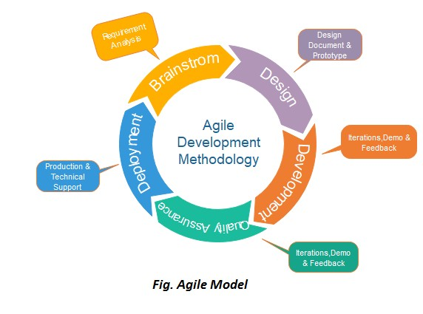

3.3 TESTING PLANS
Software testing is a critical element of software quality assurance and represents the ultimate review of specification, design and code generation. Software testing is an activity to check whether the actual results match the expected results and to ensure that the software system is defect free. It involves execution of a software component or system component to evaluate one or more properties of interest.

3.3.1 OBJECTIVE OF TESTING
- The first and the foremost objective of the software testing are to ensure that it fulfills all the requirements of the user, which means firstly understanding the user requirements and then ensuring it behaves in the similar manner.
- To providing a better user experience.
- To evaluate security related issues for the app under test.
- To evaluate the overall performance of the app.
- To uncover an as-yet-discovered error.

3.3.2 TEST CASES

Table 1: TEST CASE
Test  Case ID | Purpose | Test Case | Expected Result
TC1 | Chapter Test | Complete MCQ test and submit | Show score and correct answers.
TC2 | Mock Exam | Run full mock exam until time runs out | Auto-submit test and display final score.
TC3 | Intelligent Practice | Answer several questions wrong in one topic | Next questions focus on that weak topic.
TC4 | AI Doubt Assistant | Ask chatbot a subject-related question | Receive a relevant answer or resource suggestion.
TC5 | Performance  Analytics | View analytics after tests | Display charts for accuracy, speed, and topic-wise scores.
TC6 | Previous Attempts | Open “History” and | Show past test
 |  | select a past test | details: score, date, and review options.
TC7 | Topic Filter | Filter MCQs by selected topic in practice mode | Display only questions from the chosen topic.

3.4 Use-Case Diagram
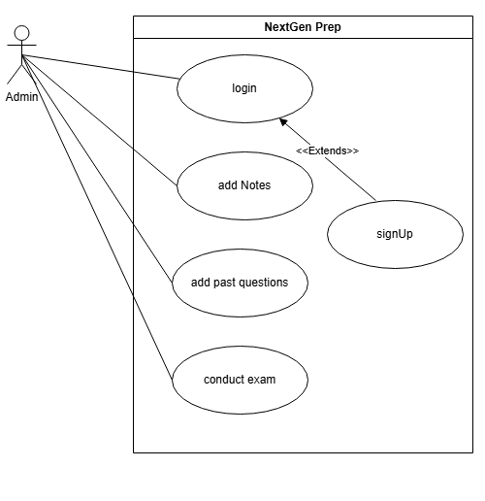
FIGURE 3.1: USE CASE DIAGRAM FOR ADMIN
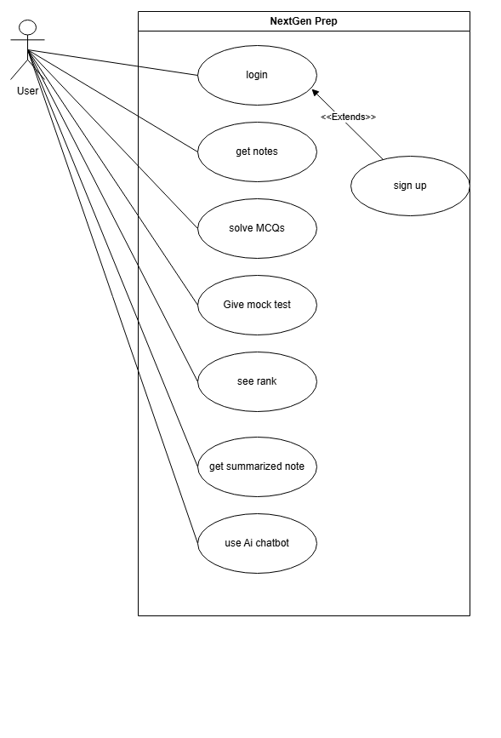
FIGURE 3.2: USE CASE DIAGRAM FOR STUDENT

USE CASE: NextGen Prep
Actors:
- Student: A user who prepares for entrance exams using NextGen Prep’s features.
- Admin: Manages content (questions, notes, resources), handles user issues, and maintains the system.

Use Cases:
- Login: Students and admins log in using secure authentication.
- Logout: Users can log out from the system at any time.
- Practice MCQs: Students can solve subject-wise and chapter-wise multiple-choice questions.
- Take Mock Tests: Students attempt full-length mock exams simulating real test conditions.
- Ask AI Chatbot: Students ask doubts or request summaries, which the chatbot answers using Gemini API.
- Track Performance: Students view their performance via dashboards and analytics.
- Access Study Materials: Students browse past papers, notes, and concept summaries in one place.
- View Result History: Students can view previous test results and performance trends.
- Update Profile: Students can edit their personal and academic details.
- Manage Content (Admin): Admins add, update, or delete questions, notes, and test content.

3.5 Entity Relation Diagram (EDR)
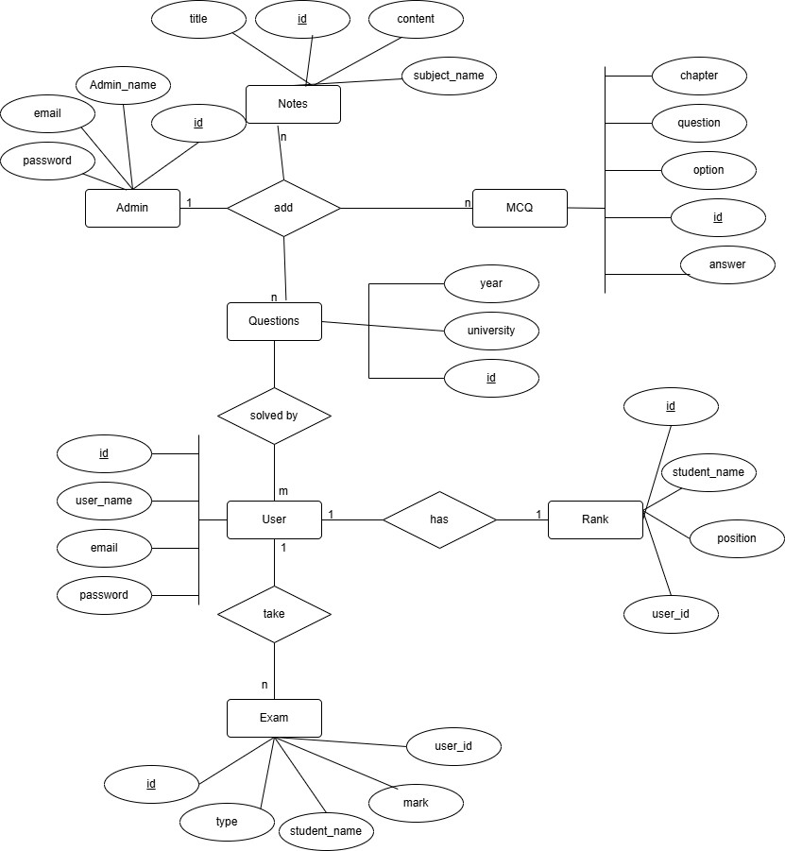
FIGURE 3.3: ENTITY RELATIONSHIP DIAGRAM

3.6 System Sequence Diagram (SSD)
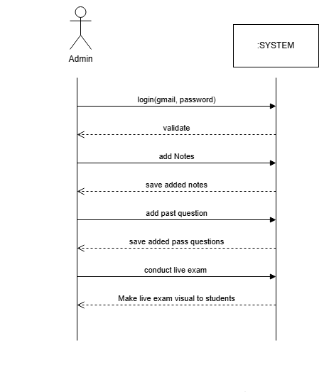
FIGURE 3.4: SYSTEM SEQUENCE DIAGRAM FOR ADMIN

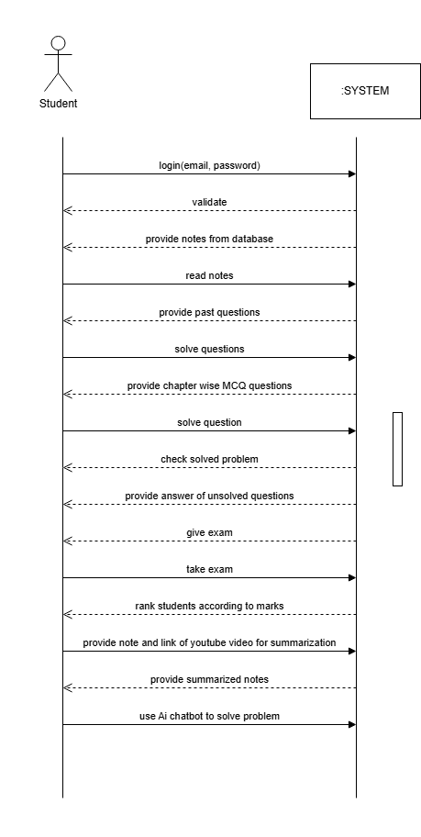
FIGURE 3.5: SYSTEM SEQUENCE DIAGRAM FOR STUDENT

CHAPTER 4
TIME LINE CHART
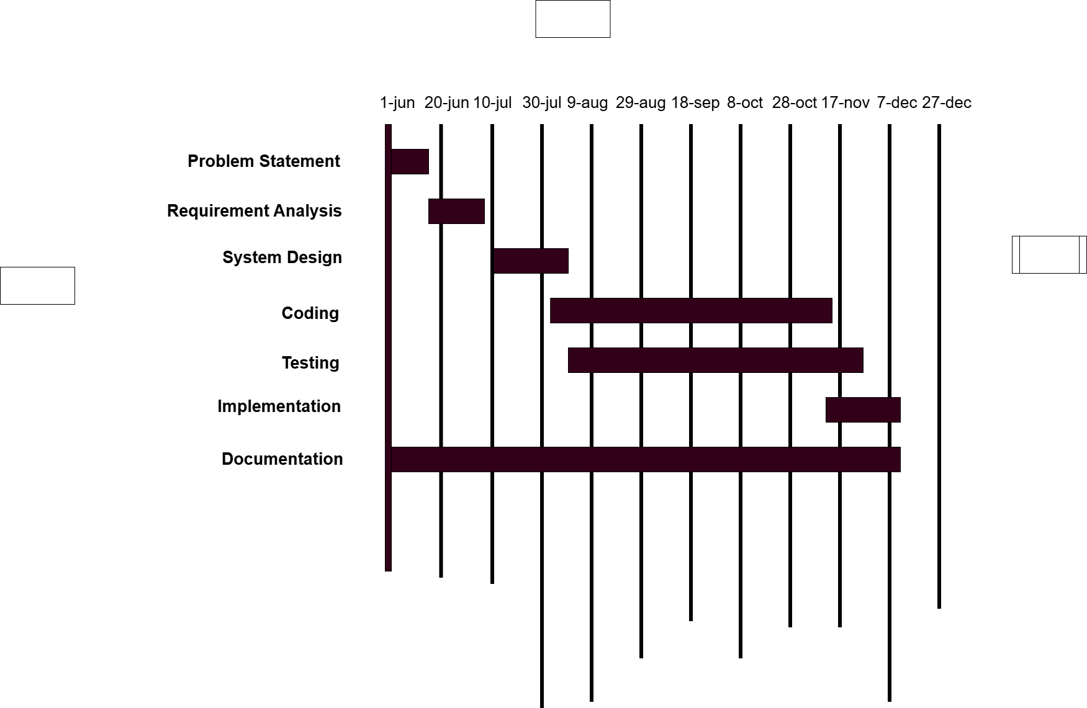
FIGURE 4: TIME LINE CHART

CHAPTER 5
EXPECTED OUTCOMES

After analyzing the requirements and defining the goals for NextGen Prep, we anticipate the following outcomes:
- Students receive personalized practice paths that adapt to their strengths and weaknesses.
- AI-powered doubt assistance delivers instant, accurate answers and resource suggestions.
- Performance analytics dashboards provide clear insights into accuracy, speed, and topic mastery.
- Mock tests and chapter-wise MCQs simulate real exam conditions, boosting confidence and time management.
- Summarization tools for PDFs and videos save study time by highlighting key concepts.
- Users can review past attempts to track progress and focus on areas needing improvement.

5.1 WIREFRAME
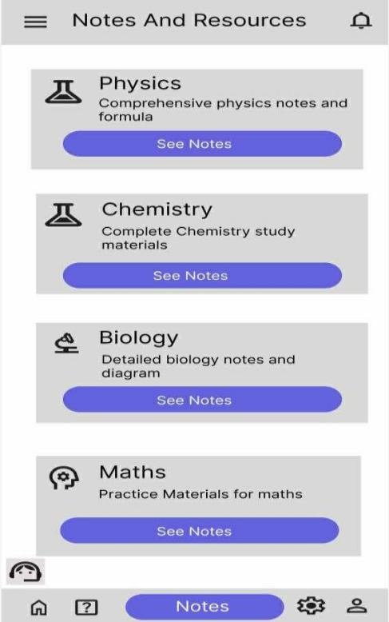

FIGURE 5.1 NOTES PAGE
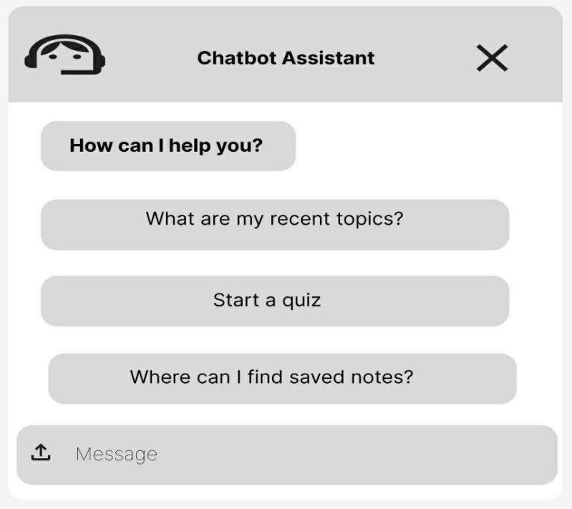
FIGURE 5.2: CHATBOT PAGE
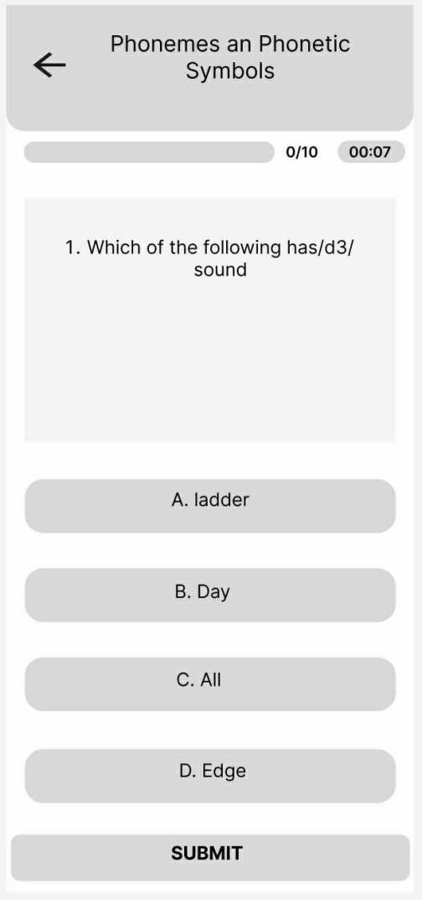
FIGURE 5.3: MCQs PAGE

BIBLIOGRAPHY
[1] J. Shi, "Design of Higher Education Information Recommendation System Based on Data Mining," 2021 International Symposium on Advances in Informatics, Electronics and Education (ISAIEE), pp. 318–321, doi: 10.1109/ISAIEE55071.2021.00079.
[2] N. Yanes, A. M. Mostafa, M. Ezz, and S. N. Almuayqil, "A Machine Learning-Based Recommender System for Improving Students Learning Experiences," IEEE Access, vol. 8, pp. 201218–201235, 2020, doi: 10.1109/ACCESS.2020.3036336.
- P. Winkler, et al., "Conversational Agents in Education: A Systematic Review," Computers & Education, 2021.
- C. Romero and S. Ventura, "Data mining in education," Wiley Interdisciplinary Reviews: Data Mining and Knowledge Discovery, 2013.
- Mero Sikai, “Mero Sikai – Nepali Exam Preparation App,” Mobile Application, 2024.
- Sikshalaya, “Sikshalaya – College and Course Information,” Web Portal, 2024.
- ExamSathi, “ExamSathi – Entrance Exam Practice,” Mobile Application, 2024.
- Edusanjal, “Edusanjal – Educational Portal for Nepal,” Mobile Application, 2024.
- PrepAir, PrepAir – Entrance Preparation App, Apple App Store.
- LiveGuru Nepal, LiveGuru Nepal – Medical Entrance Preparation, Google Play Store.

